Parallel Random Access Machine (PRAM)

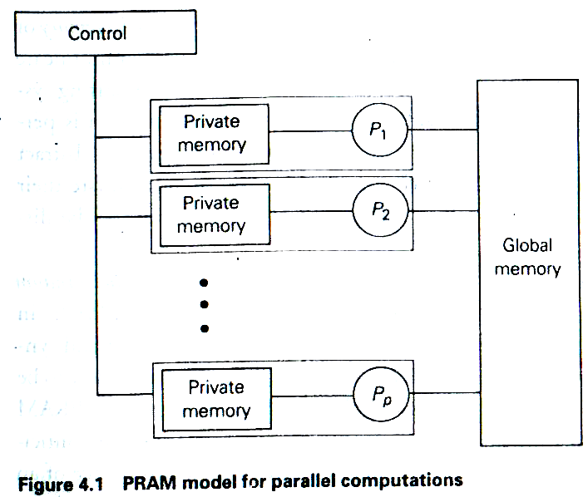

Read/Write Modes
1. Exclusive Read (ER)
2. Exclusive Write (EW)
3. Concurrent Read (CR)
4. Concurrent Write (CR)
Common, Arbitrary, Minimum (P-index), Reduction (sum/min/max)

Sub Classes of PRAM

EREW PRAM
ERCW PRAM
CREW PRAM
CRCW PRAM

Multiple Accesses on EREW

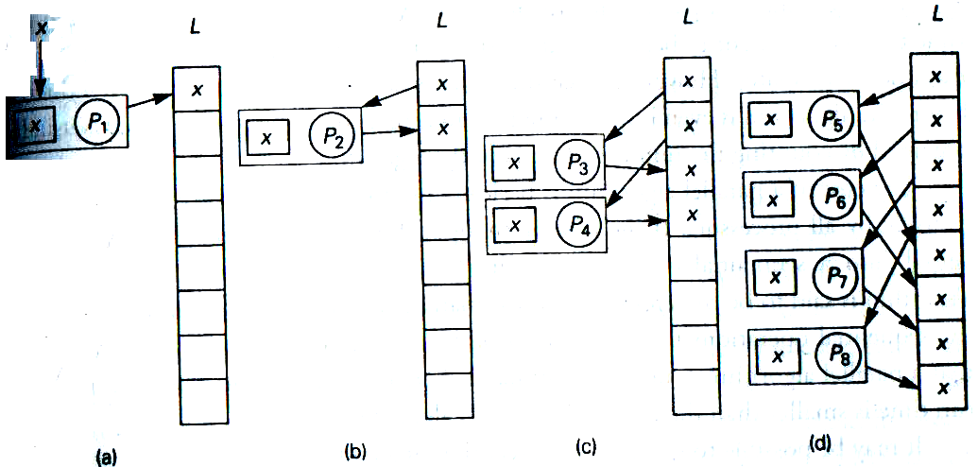

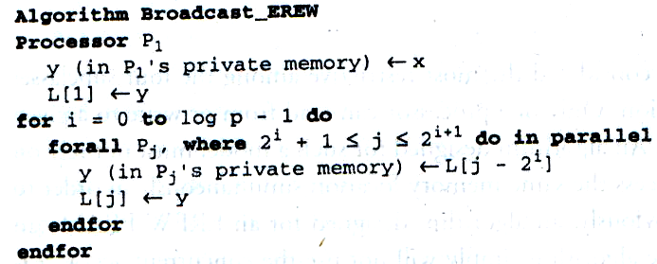

Complexity Analysis

Run Time ➔ T(n)
Number of Processors ➔ P(n)
Cost ➔ C(n) = T(n) * P(n)

Computing Sum of an ARRAY on EREW PRAM

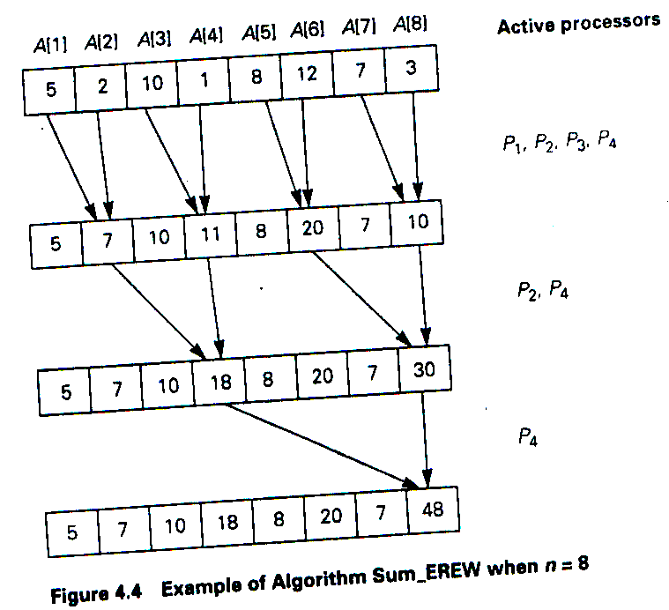
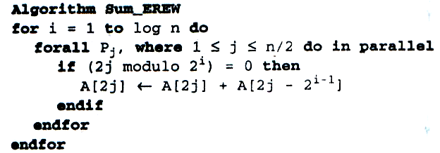

Complexity Analysis

Run Time ➔ T(n)
Number of Processors ➔ P(n)
Cost ➔ C(n) = T(n) * P(n)
Computing all Partial Sum

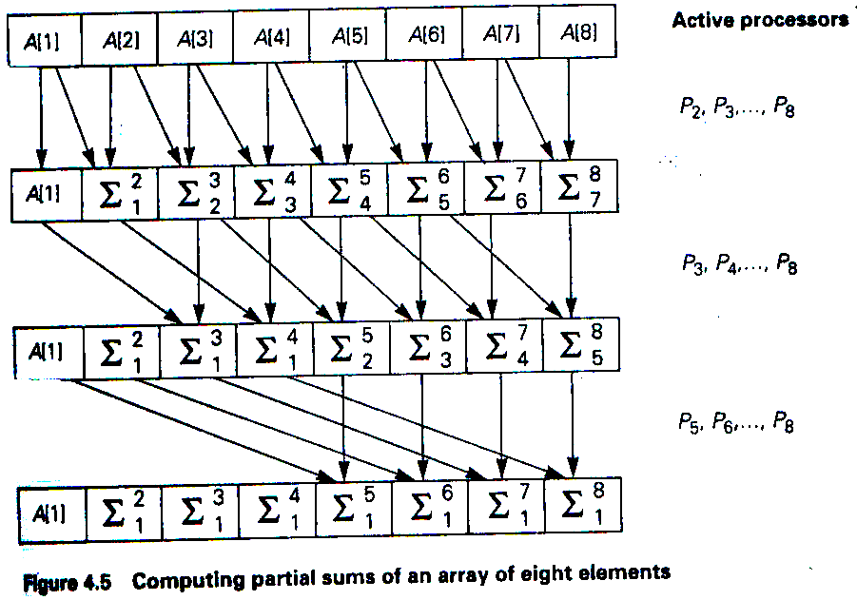
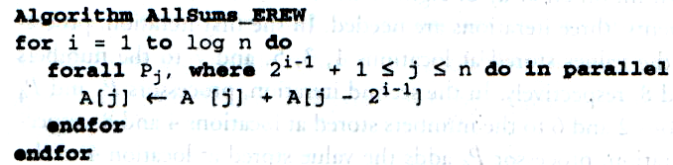

Complexity Analysis

Run Time ➔ T(n)
Number of Processors ➔ P(n)
Cost ➔ C(n) = T(n) * P(n)

Matrix Multiplication (CREW PRAM)
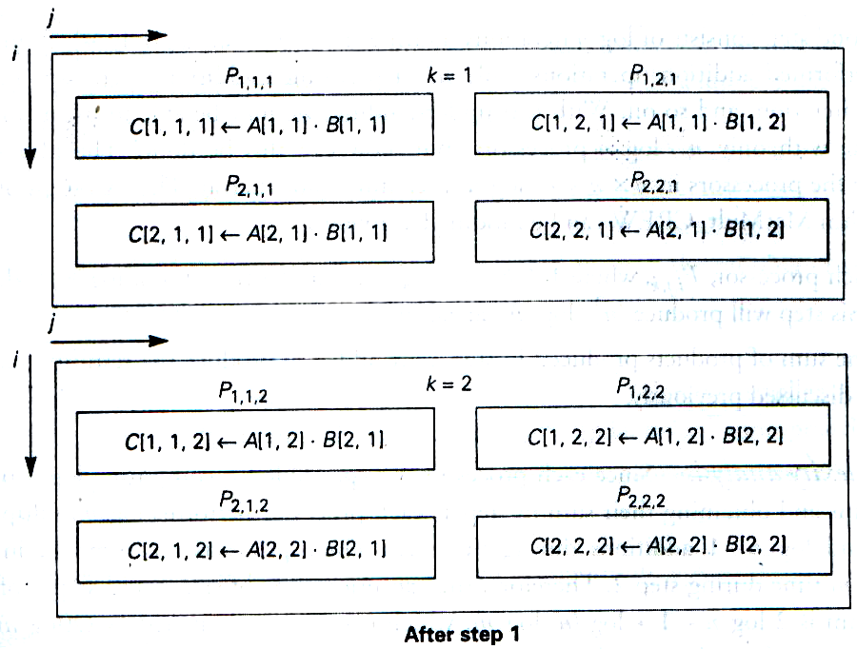

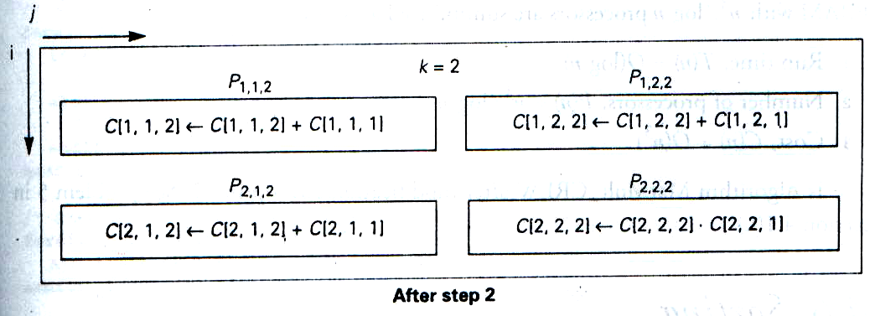

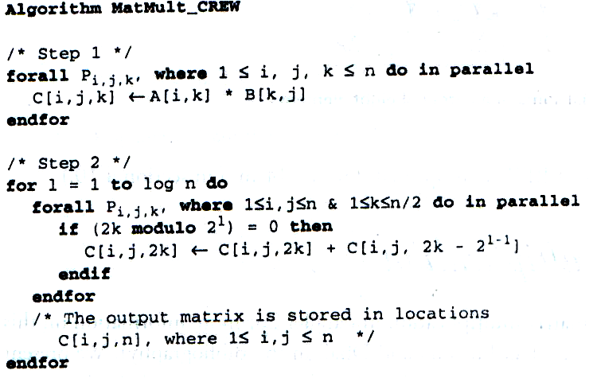

Complexity Analysis

Run Time ➔ T(n)
Number of Processors ➔ P(n)
Cost ➔ C(n) = T(n) * P(n)

